





INTERNATIONAL CORPORATE LEADERSHIP (1)
2005/2006

MODULE HANDBOOK

CSER 3010
Jane Conway
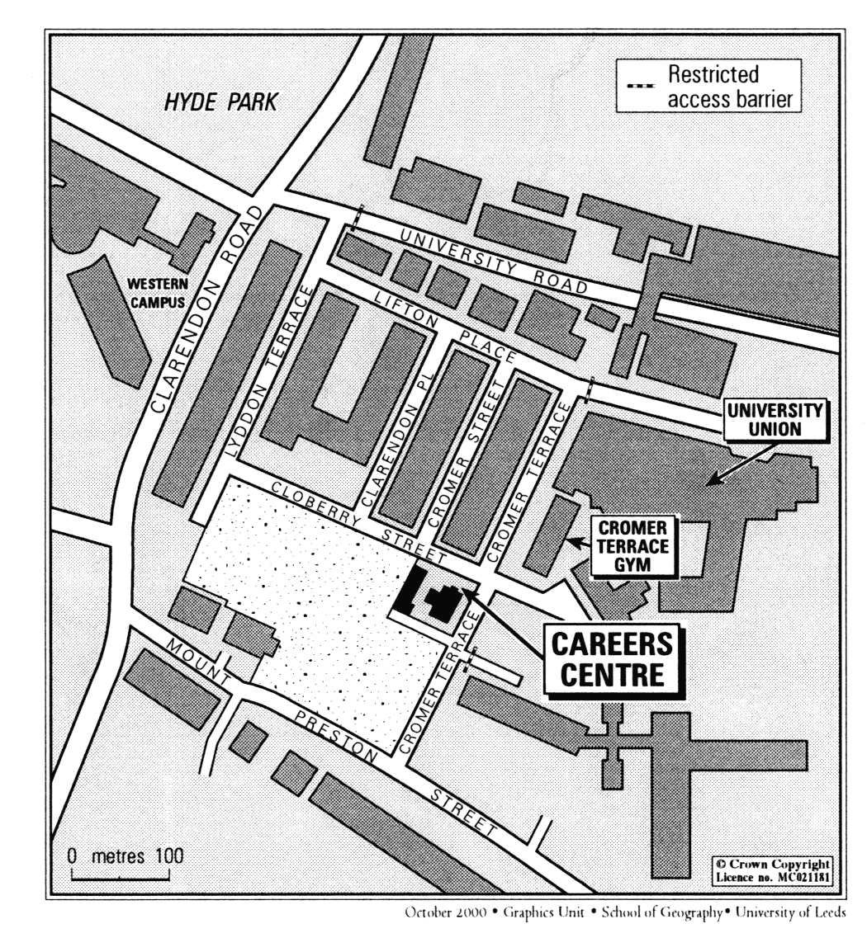

SECTION A: Basic information

- Introduction

Welcome to ICLP1. This module aims to build on students experience gained from industrial placement, to develop an appreciation of leadership and management and how to apply such knowledge through personal skills such as teamwork, communication and decision-making.

- Aims of the International Corporate Leadership programme

<TBODY>The programme is designed specifically to satisfy a need identified by leading industrial companies for high quality engineering, IT and business graduates who possess a wider skill base that includes international, business and leadership awareness and experience as well as communication and teamwork skills.

Objectives of ICLP (1) module

On completion of this module, students will be able to:

- In a supportive learning environment, discover, explore and: experiment with issues about themselves and how they relate to, or work with, others including
- an assessment of the relative benefits of their own leadership style;
- the application of theories of group dynamics to maximise output from team tasks.

- Translate strategy into action by:
- developing action plans and setting objectives for personal development during summer placement, and for future success;
- evaluating their own success in meeting objectives.

- Analyse the importance of cross-cultural understanding/flexibility within the context of increasing globalisation of UK industrial practice.

- Apply creative thinking to the development and promotion of ideas for entrepreneurial products or services.

To take part in this Programme you will have undergone a selection process, based partly on academic performance to date. Assessment for this module will not measure your technical ability within your degree subject; we assume that all ICLP students will be competent in their chosen disciplines on completion of their studies.

In this module we will be encouraging you to think more broadly about what constitutes successful leadership, in any context, and giving you the opportunity to work with students from other subjects in multi-disciplinary teams. We expect you to reflect on that experience to identify the factors which influence effective group task completion, focusing particularly on your own role within the process.

Assessment for this module requires a level of self-reflection which may be unfamiliar to some of you. You will be expected to critically analyse your own performance and apply theoretical concepts to assess your strengths in team work/task completion and leadership. You will also be expected to identify areas for development of your own performance and suggest ways in which you could enhance that development.

- Who should take this module?

This module is compulsory for all students taking part in the International Corporate Leadership Programme.

- Prerequisites

Selection for International Corporate Leadership Programme and normally, completion of one industrial placement through the Programme are the prerequisites for this module. However, it is recognized that some individual circumstances may vary.

- Credits

This course is worth ten credits at Level 3 if successfully completed.

- Content & timetable

Due to the diversity of students that will be taking this course, the workshops are held on Wednesday afternoons, between 2:00pm and 4:00pm, in Leeds University Careers Centre. The workshop on Wednesday 15th March will run from 1pm – 5pm.

In addition to the Wednesday afternoon workshops there will be one full day workshop on Saturday 4th Feb 2006.

The time-table for the 2005-2006 session is:

Date | Topic | Other info
Session 1  Wed 25th Jan  2pm - 4pm | Introductions to :  - Module  - Style of working  - Assessment schedule /ICLP Prize  - Leadership issues | Venue:  Careers Centre
Session 2  Wed 1st Feb  2pm - 4pm | Group dynamics and task management  - MBTI  - Intro to Entrepreneurship: case study | Venue:  Careers Centre
Saturday  4th Feb | Introduction to Leadership  Activity day | Venue:  Careers Centre
Session 3  Wed 8th Feb  2 – 4 pm | Group dynamics continued  - Issues of motivation  - Values (personal, organisational) | Venue:  Careers Centre
Session 4  Wed 15th Feb  2pm - 4pm | Cultural issues:  - International  - Organisational  - Communication | Venue:  Careers Centre
Session 5  Wed 22nd Feb | Case study presentation preparation | Venue:  Not specified
Session 6  Wed 1st March  2pm – 4pm | - Case Study presentations | Assessed  Venue:  Careers Centre
Session 7  Wed 8th March  2pm - 4pm | Professional Development and transferable skills. | Venue:  Careers Centre
Session 8  Wed 15th March  1pm - 5pm | Future Search workshop  Poster presentations  ICLP prize will be judged | Assessed  External presenter  Venue: TBC

- Assessment

Assessment is by means of three pieces of assessed coursework :

Assessment | Weighting | Deadline
Group presentation of case study results:  15 minute group presentations showing teamwork, creativity, entrepreneurial thinking and commercial awareness. | 30% | 1st March
Poster presentations:  Showing appreciation of the benefits of ICLP to companies and individuals.  (Also submitted for ICLP Prize) | 30% | 15th March
Individual report on group task:  Critical report of performance showing an understanding of group dynamics, leadership styles and own development needs - 2,000 words. | 40% | 24th March

Individual report on group task must be submitted to the pigeon hole via the Nathan Bodington Building. (See Section B)

What is required to achieve a particular grade of mark in this module (first, upper second etc.) is set out under Marking Criteria in Section B.

Please read the rules governing the submission of coursework, including penalties for late submission, and the University’s rules about plagiarism and cheating. (See section B).

ICLP Prize

The poster presentations submitted for assessment at the Future Search workshop on 15th March will also be assessed for the award of the ICLP Prize.

The prize money of £250 has been donated by Shell and will be awarded to the students who, in the opinion of the judges, best illustrate:
- The business benefits of an ICLP placement (to the sponsoring company)
- The skills ICLP students have to offer the placement organisation

1st prize £125
2nd prize £75
3rd prize £50

Contacting your module leader

Jane Conway
Or make an appointment via Careers Centre Reception, Tel ext 35295

Please contact your tutor sooner rather than later if you are anxious about the course or in any difficulty.

- Administration

The module is administered by:

Caroline Shingles

SECTION B: Further information

Work Requirements

The work requirements associated with this course are as follows:

- attendance at workshops
- preparation for workshops
- reading as directed
- group presentation of assessed coursework
- submission of assessed coursework

Attendance at classes is compulsory and is recorded. Where there is a good reason for absence please let the module leader know, in advance if possible. Failure to meet the work requirements may lead to exclusion from the course.

Even if that does not occur, failing to meet the work requirements is likely to reduce your chances of obtaining a good result.

Student Feedback and Complaints

Feedback
The University requires student feedback to be obtained and evaluated for each module in every session.

Complaints
The University and the Careers Centre have a well-defined student complaints procedure. You can obtain details of this from the Careers Centre reception.

Rules of submission for the Assessed Individual Report on Group Task:

- Locate the Nathan Bodington building on the WWW Address http://vle.leeds.ac.uk/site/
Any problems contact the Bodington Common Help Desk on 0113 34 35310

- When logged in –

- Click on Nathan Bodington building
- Click on Student Support Floor
- Click on Careers Centre
- Click on CSER 3010

If you cannot see a suite of rooms within the floor please contact Caroline Shingles and she will arrange access for you.

You should now be able to see the following rooms:-

- Teaching Materials: contains materials for the course

- Assessment details – contains assessment details and marking criteria.

- Pigeon hole – for the assessed report on group task

When you are ready to submit –

- DO NOT FORGET TO INCLUDE A HEADER OR FOOTER CONTAINING YOUR NAME AND SID NUMBER on your work
- Copy your file to your hard drive or home directory (working directly from a floppy disk can cause file corruption and loss of data)
- Read and agree to the ‘Declaration of Academic Integrity’
- Click on the relevant pigeon hole check that the status states ‘you are accessing this tool as your username’. Click on ‘put file in pigeon hole’ - You can browse your files until you find the correct one. Make sure you change the ‘files of type ‘ from HTML ’ to ‘all files’ so that you can find your word document. Then press ‘send now’.

After the deadline has passed, the files will be locked whilst they are being marked. The comments and marks will then be emailed to you.

Late Submission of Assessed Coursework
The University attaches penalties to the late submission of assessed coursework. You need to be familiar with the University’s rules. Details can be found in the Undergraduate Handbook.

- Plagiarism, Cheating, etc.
Offences in this area can result in attendance at a University-level committee and penalties including expulsion from the University. You need to be familiar with the rules. The details can be found in the Undergraduate Handbook.

Student Complaints Procedure
An advisory leaflet on using this procedure can be obtained from your personal tutor.

Marking Criteria
The course will be assessed by the success criteria set out below to demonstrate what is required to achieve a first class, upper second class etc. mark on this module.

Module Grade Scale:

80 - 90 Outstanding - attaining the highest professional standards in every respect.
(Excellent First)

70 - 79 Excellent - first rate work in most respects, showing e.g. full understanding of purpose; knowledge of related work; choice and use of appropriate methods; originality; well-developed skills; personal commitment.
(First Class)

60 - 69 Very Good - showing strength in many respects, e.g. appreciation of needs; marshalling of relevant material; logical approach; sound interpretation; good presentation; persistence.
(Class IIi)

50 - 59 Good - solid work, showing some limitations, e.g. understanding of requirements; choice of approach; development of argument; use of references and background material; layout application.
(Class IIii)

45 - 49 Satisfactory - basically sound, but showing weaknesses, e.g. grasp of concepts; knowledge of related work; planning; interpretation of findings; clarity of presentation; effort.
(Class III)

40 - 44 Adequate - showing appreciation of aims, but significant lapses, e.g. understanding; choice and use of procedures; development of argument; soundness of conclusions; personal commitment.
(Bare Pass – Low Class III)

20 - 39 Fail - showing failure to understand aims; confusion over e.g. plans, methods, arguments, meanings; lack of effort.

NSA – No Serious Attempt

ABS – Absent or no Attempt

